**SmartTech Solution Pvt. Ltd.**

Thapagaun, New Baneshwor

Kathmandu, Nepal

+977 - 01 - 5245027

**User Manual**

**For**

**Asset Management**

**Dashboard ( Web )**

# 

**1. Getting started with the Web Dashboard** **2**

1.1 About the Web Dashboard 2

1.2 Accessing the Web Configuration Panel 2

**2. Using Web Dashboard** **2**

2.1 Home 2

2.1.1 Income & Expenditure Visualization 3

2.1.1.1 All Time 3

2.1.1.2 This year 4

2.1.2 Maintenance Cost Visualization 4

2.1.2.1 All Time 4

2.1.2.2 This year 5

2.2 Finance 6

2.2.1 Visualization 6

2.2.1.1 All Time 6

2.2.1.2 This Year 6

2.2.2 Cashbook 7

2.3 Maintenance 8

2.3.1 Cost Visualization 8

2.3.1.1 All Time 8

2.3.1.2 This Year 9

2.3.2 Asset Components 10

2.4 Service 10

2.4.1 Supply Visualization 10

2.4.2 Quality Test Result 11

2.5 Change Language 12

2.6 Logout 12

# 

# 1. Getting started with the Web Dashboard

## 1.1 About the Web Dashboard

The Web Dashboard enables you to view the Overall Net Balance, Beneficiary Details, Supply Schedule, Tariff rates, and General information of the water system. This also helps to know about the different financial records of the year, maintenance Information, cost visualization, etc. This web Dashboard will guide you through different tabs and sub-tabs including the visualization of the graph.

## 1.2 Accessing the Web Configuration Panel

You can access the Web Dashboard using any compatible browser installed on your PC. To log in to the web Dashboard, you will need the authorized Link.

# 2. Using Web Dashboard

When a Water System’s User logs in to the web application, the Dashboard is the first screen he/she will see.

## 2.1 Home

In the Dashboard’s Home tab, users can view the Overall Net Balance, General Information, Beneficiary details, Supply Schedule, Tariff rates, and Graph visualization of the Water System. 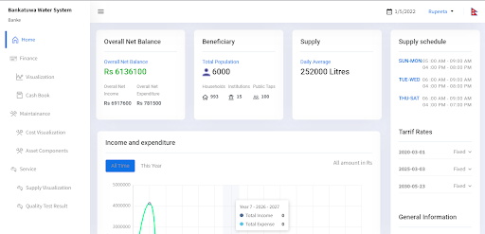

### 2.1.1 Income & Expenditure Visualization

In the Visualization Graph of Income & Expenditure, users can view the Income and Expenditure of different years with respective months of the water system. There is a visualization graph for:

1. All Time
2. This Year

#### 2.1.1.1 All Time

In the All-time visualization graph, users can view the income and expenditure for the different years only. If the user clicks on the graph for Year 1, then he/she will be able to see the total income and expenses for that year. Likewise, to view other Years’ income and expenditure, users can click on the graph of different years.



#### 

#### 2.1.1.2 This year

In This year's visualization graph, users can view the income and expenditure for the current year with respective months.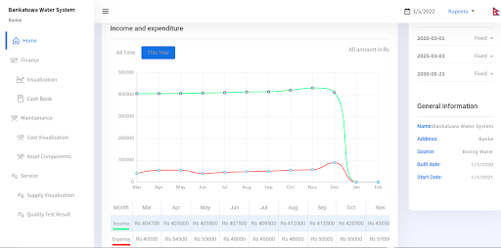

### 2.1.2 Maintenance Cost Visualization

In the Visualization Graph of Maintenance Cost, users can view the maintenance cost for different years with respective months of the water system. There is a visualization graph for:

1. All Time
2. This year

#### 2.1.2.1 All Time

In the All-time visualization graph, users can view the maintenance cost like Expected unsegregated, expected material, expected labor, expected replacement, Actual unsegregated, actual material, actual labor, and actual replacement cost. If the user clicks on the graph for Year 1, then he/she will be able to see the maintenance cost for that year. Likewise, to view other years' maintenance costs, users can click on the graph of different years.

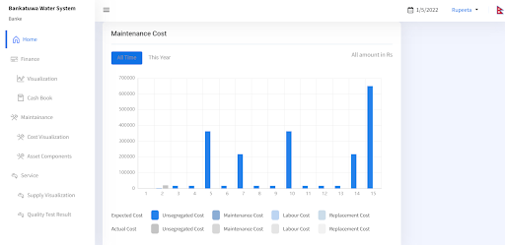

#### 2.1.2.2 This year

In This year's visualization graph, users can view the maintenance cost (Segregated and Unsegregated) for the current year with their respective months.

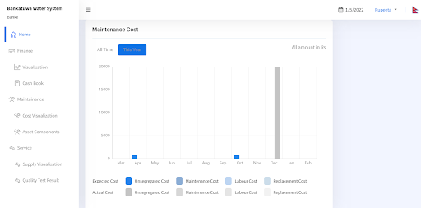

## 

## 2.2 Finance

In the Finance tab, there are mainly two tabs. They are Visualization and Cashbook.

### 2.2.1 Visualization

In the Financial data visualization graph, there is a visualization graph for All Time & This Year.

#### 2.2.1.1 All Time

In the All-time Financial visualization graph, users can view the financial data for the different years. On the right side of the tab, there is a visualization parameter that needs to be selected by the user in order to see the financial records in a graph for different years. Users can see Actual Income, Actual Expenses, Actual Cumulative Cash Flow, Expected income, Expected expenses, and Expected cumulative cash flow.

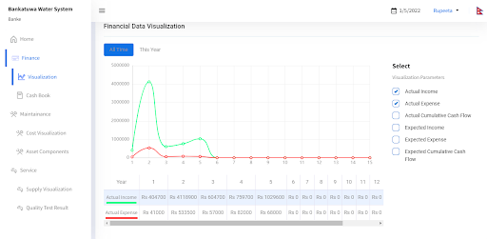

#### 2.2.1.2 This Year

In This year's Financial data visualization graph, users can view the financial data for the current year with their respective months. On the right side of the tab, there is a visualization parameter that needs to be selected by the user in order to see the financial records in a graph for different months of the current year. Users can see Actual Income, Actual Expenses, Actual Cumulative Cash Flow, Expected income, Expected expenses, and Expected cumulative cash flow.

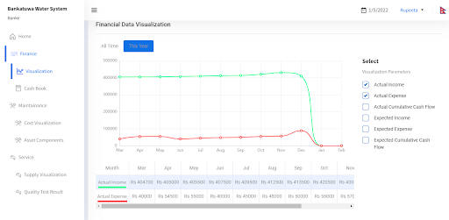

### 2.2.2 Cashbook

In the cashbook tab, users can see the cash book record regarding income and expenses by selecting different year dates. This cashbook record shows the total amount and the previous month’s total as per the different income and expenses headings. 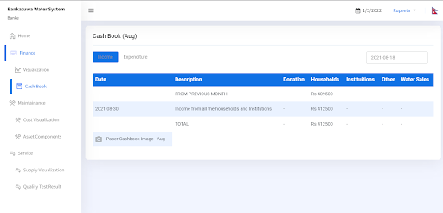

## 2.3 Maintenance

In the Maintenance tab, there are mainly two sub-tabs. They are Cost Visualization and Asset Components.

### 2.3.1 Cost Visualization

In the Maintenance Cost Visualization graph, there is a visualization graph for All Time & This Year.

#### 2.3.1.1 All Time

In the All-time maintenance visualization graph, users can view the maintenance record data for different years. On the right side of the tab, there is a visualization parameter that needs to be selected by the user in order to see the maintenance records in a graph for different years. Users can see Actual unsegregated, Actual material, Actual labor, Actual replacement, Expected unsegregated, Expected material, Expected labor, and Expected Replacement.

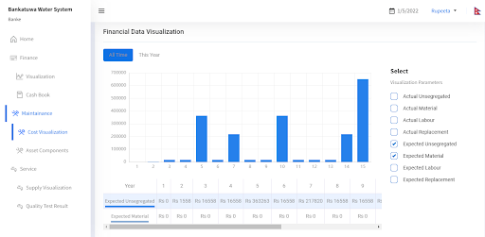

Maintenance Cost Distribution- Actual & Maintenance Cost Distribution- Planned data can be seen in the table below the maintenance cost visualization graph.

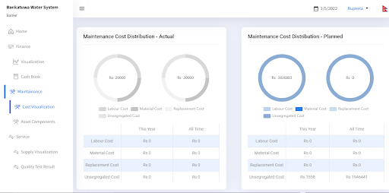

#### 2.3.1.2 This Year

In this year's Financial data visualization graph, users can view the financial data for the current year with the respective months. On the right side of the tab, there is a visualization parameter that needs to be selected by the user in order to see the maintenance records in a graph for different months of the current year. Users can see Actual unsegregated, Actual material, Actual labor, Actual replacement, Expected unsegregated, Expected material, Expected labor, and Expected Replacement.

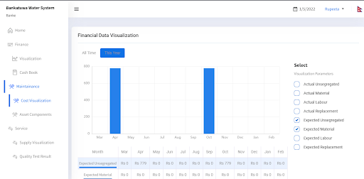

### 2.3.2 Asset Components

In the Asset Components, users can see the list of Asset Components with the description of Possible Failure, Mitigation, Responsible, Risk and Cost. If the users click on the Risk button, they will be able to see the brief descriptions of failure with a risk score for an asset component. Similarly, if the users click on the Cost button, they will be able to see the required cost of an asset component for maintenance.

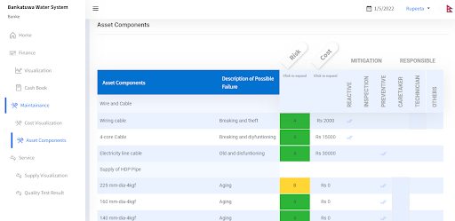

## 2.4 Service

In the Service Tab, there are mainly two sub-tabs. They are Supply Visualization and Quality Test Results.

### 2.4.1 Supply Visualization

In the supply visualization graph, users can view the water supply for All time, This Year, This Month & for This week. By selecting the visualization parameters, users will be able to see the Daily Average Line and Total Supply. By selecting different dates of the year, users can view supply data.

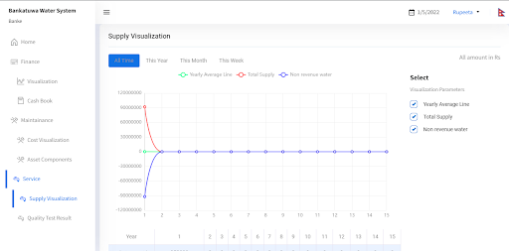

### 2.4.2 Quality Test Result

In the Quality Test Result, users can view the Quality test result of Water for All Time & This Year. By selecting the different water parameters, users can see the quality test result for water.

## 

## 2.5 Change Language

There is an availability of two languages: English and Nepali in the configuration web utility. Users can select the language by:

* Clicking on the top of the right corner where there is an icon of Flag in the configuration panel.

## 2.6 Logout

Users can logout from the web configuration by:

* Clicking on the name of the User placed on the right side of the panel near the language selection and clicking on the Logout displayed text.

**Thank you**